2020 Leaving Cert Physics Paper (Higher Level)

2020 Question1
A student performed an experiment to investigate the principle of conservation of momentum.
He released one trolley and it travelled along a track and collided with a second trolley at rest.
After the collision, the trolleys stick together (their masses are combined) and they travel along the track.
Before setting up the experiment, the student measured the mass of each trolley.

Mass of trolley A = 0.38 kg
Mass of trolley B = 0.35 kg
- Draw a labelled diagram of the apparatus used in this experiment.
- How did the student measure the masses of the trolleys?

To calculate the velocity of the trolleys, the student measured distance and time.
- Describe how the distance was measured.
- Describe how the time was measured.
- How did the student use the distance and the time to calculate the velocity?

Starting velocity of trolley A = 1.5 m s^{–1}.
Starting velocity of trolley B = 0 m s^{–1}.
Final velocity of trolleys A and B together = 0.78 m s^{–1}.

The principle of conservation of momentum states that the momentum before the collision is equal to the momentum after the collision.
- The momentum of trolley A before the collision = 0.38 × 1.5 = 0.57 kg m s^{–1}.
- What is the momentum of trolley B before the collision?
- Calculate the combined momentum of trolleys A and B after the collision (Show your work.)
- Was momentum conserved in this collision? Explain your answer.

2020 Question 2
A student carried out an experiment to measure the focal length of a concave mirror.
- Draw a labelled diagram of the apparatus used in this experiment.
- State the formula used to calculate the focal length.
- On your diagram, indicate and label the measurements taken by the student.
- What instrument was used to take these measurements?
- Why did the student measure the approximate focal length at the start of the experiment?
- The image distance is the less accurate measurement. Explain why.

2020 Question 3

A student carried out an experiment to investigate how the fundamental frequency of a stretched string changes with length.
- Draw a labelled diagram of the apparatus used in this experiment.
- On your diagram, indicate and label the length measured by the student.

The student completed the following graph to show the relationship between length and frequency.
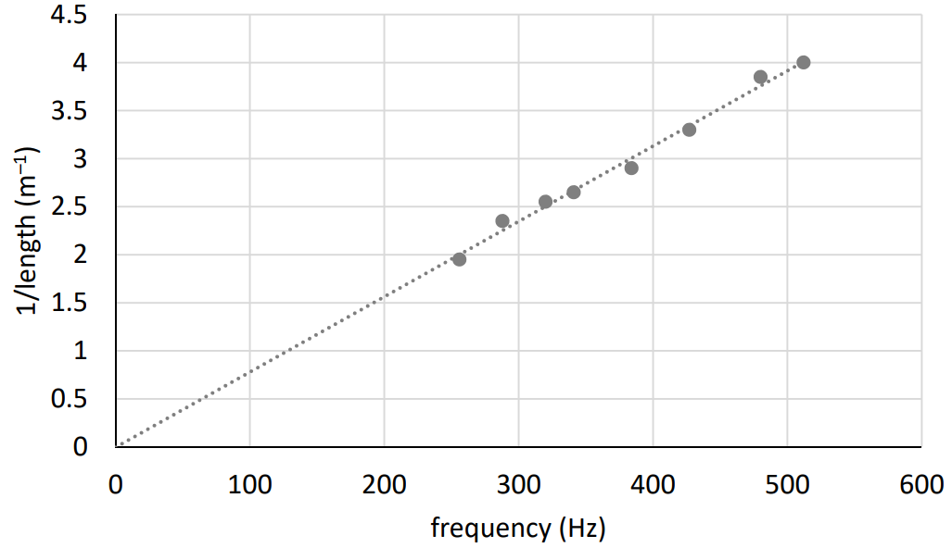

- How did the student measure the frequency values?
- How did the student set the string vibrating?

The length between the bridges is adjusted until resonance occurs.
- Describe how the student knew that resonance had occurred.
- State the relationship between the resonance frequency and the length.

2020 Question 4
A student performed an experiment to investigate how the resistance of a metallic conductor changes with temperature.
- Name the instrument used to measure resistance.
- Name the instrument used to measure temperature.
- How did the student change the temperature of the metallic conductor?
- The student recorded the following data:

Temperature (°C) | 10 | 20 | 30 | 40 | 50 | 60 | 70
Resistance (Ω) | 4.8 | 5.4 | 6.0 | 6.6 | 7.2 | 7.8 | 8.4

- Use the data to plot a graph to show the relationship between resistance and temperature.
- Describe the relationship between resistance and temperature.
- State one safety precaution that the student should have taken.

2020 Question 5
Answer any eight of the following parts (a), (b), (c), etc.
- Explain Archimedes’ principle. The diagram may help you answer.
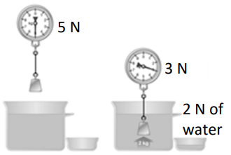
- What is meant by latent heat?
- Which of the following is the SI unit of capacitance?
ampere coulomb farad volt
- State Boyle’s law.
- An electric heater has a power rating of 1500 W.
It uses a voltage of 230 V. Which fuse should be used in the plug, a 3 A fuse or a 13 A fuse?
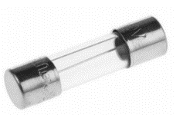
Justify your answer.

- What is a magnetic field?
- Ultraviolet light is on the electromagnetic spectrum. State two properties of ultraviolet light.
- A pair of complementary colours consists of a primary colour and a secondary colour that mix to give white light. Name a pair of complementary colours.

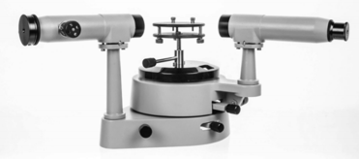
- Name the piece of equipment on the right.

- What is nuclear fusion?

2020 Question 6
Sir Isaac Newton was an English mathematician and physicist.
He is widely recognised as one of the most influential scientists of all time.
Newton’s first law of motion states that a body remains at rest or moving at a constant velocity unless an unbalanced external force acts on it.

- A block weighs 400 N. A crane lifts the block so that it moves upwards with constant velocity.
Use Newton’s first law of motion to find the force that the crane puts on the block.

Newton’s second law of motion states that the force on an object is proportional to its rate of change of momentum.
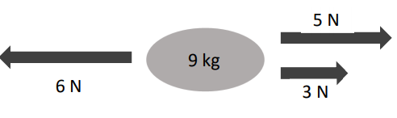

- Calculate the resultant (net) force on the 9 kg object in the diagram above.
- In what direction does it act?
- Calculate the acceleration of the 9 kg object.

- State Newton’s third law of motion.
- Use Newton’s third law to explain how a rocket takes off. (A labelled diagram may help your answer.)

A car of mass 700 kg is at rest.
It accelerates at a constant rate for 6 seconds until it is travelling at a velocity of 18 m s^{–1}.
- Calculate the kinetic energy of the car when it is travelling at 18 m s^{–1}.
- Calculate the acceleration of the car.
- Calculate the net force on the car as it accelerates.

The engine of the car provides a driving force of 3000 N.
(ix) Calculate the friction acting on the car.
(x) State one method of reducing friction.

2020 Question 7
Light undergoes refraction as shown in the picture.
Refraction is the bending of light as it passes from one medium into another.
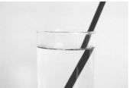
- State Snell’s law of refraction.
- Describe an experiment to demonstrate Snell’s law.
- A beam of light travelling from air strikes the surface of water.
The angle of incidence is 36° and the angle of refraction is 26°.
Use Snell’s law to calculate the refractive index of water.

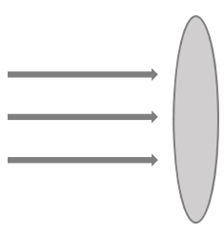
- Refractive index can also be calculated using the formula $n=\frac{1}{\sin{C}}$
What does C stand for in the formula written above?

- A converging lens refracts light.
Copy and complete the diagram below to show the paths of the rays of light after they strike the converging lens.

- A converging lens can be used to produce a magnified virtual image.
Explain the underlined term.
- A converging lens has focal length 15 cm (f = 15 cm).
An object is placed 20 cm in front of the lens (u = 20 cm).
Calculate the image distance, v.

- Calculate the magnification, m.

- State one use of a lens.

2020 Question 8
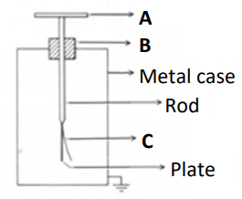
A gold leaf electroscope is used to perform experiments involving static electricity.
- Name the parts of the gold leaf electroscope labelled A, B and C.

- When two different materials are rubbed together, they become electrically charged.
Describe how a student would charge a plastic rod.

- How would the student use a gold leaf electroscope to show that the rod is charged?

- State the SI unit of electric charge.
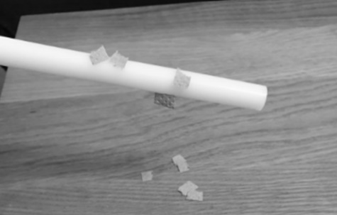
- The photograph above shows a charged plastic rod attracting small pieces of paper to it.
Explain how this happens.
- Describe, with the aid of a labelled diagram, an experiment to show an electric field pattern. On your diagram, show the electric field, including its direction.
- Coulomb’s law describes the force between static charges.
It is an example of an inverse square law.
State another example of an inverse square law.

2020 Question 9
Light travels as a wave of electromagnetic radiation. The colour of the light depends on its
frequency.
- Light is an example of a transverse wave. Explain what is meant by a transverse wave.
(A labelled diagram may help your answer.)
- Orange light has a frequency of 5 × 1014 Hz. The speed of light is 3 × 10⁸ m s^{–1}.
Calculate the wavelength of the orange light.
- Sound also travels as a wave. Sound is an example of a mechanical wave.
Describe an experiment to show that sound needs a medium to travel through.
- Sound waves undergo reflection, refraction, diffraction and interference.
What is meant by reflection?
- Describe an experiment to show the interference of sound waves.
- Sound waves do not undergo polarisation. Explain why.

- As an ambulance passes a stationary observer, its siren emits a sound of a particular frequency.
This frequency appears to change as the ambulance passes the observer.
This is caused by the Doppler effect.
Describe a laboratory experiment to demonstrate the Doppler effect.

- State one use of the Doppler effect.

2020 Question 10
Irish physicist G.J. Stoney named the electron in 1891. J.J. Thomson identified it as a particle in 1897.
- Where in the atom is the electron found?
- Compare the mass of an electron to the mass of a proton.
- Electrons are produced in a cathode ray tube by thermionic emission.
What is meant by thermionic emission?
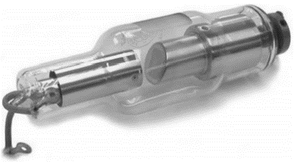
- Draw a labelled diagram of a cathode ray tube.
- How are the electrons detected in a cathode ray tube?
- State one use of a cathode ray tube.
- The photoelectric effect is the emission of electrons from the surface of a metal when light of a suitable frequency falls on it.
Describe an experiment to demonstrate the photoelectric effect.
- The picture shows an X‐ray tube. What is an X‐ray?
- Explain why the production of X‐rays can be considered to be the opposite of the photoelectric effect.
- State one danger associated with X‐rays.

2020 Question 11
Read the following passage and answer the questions below.
WHAT ARE GREENHOUSE GASES?
A wide range of gases contribute to climate change. These are known as greenhouse gases. The most important greenhouse gases are carbon dioxide (CO2), methane (CH4), and nitrous oxide (N2O). These gases contribute to the greenhouse effect by absorbing infrared radiation.
The impact of greenhouse gas emissions on climate disruption must be addressed.
Ireland has experienced the extreme weather events of flooding, drought, and heavy snow.
However, many countries have experienced much worse. Climate change is bringing about desertification, rising sea levels, displaced populations, and severe challenges to the natural world.
These have contributed to significant economic and social disruption. We are close to a tipping point where these crises will get much worse.
Decarbonisation is now a must if the world is to contain the damage and build resilience in the face of this challenge.
Agenda 2030 and the Paris Agreement on climate change require a transformational shift in our economies and societies towards sustainable development. Ireland and the international community are responding to this requirement, setting out a profound change in the practices which support our lifestyle. Every home, community, and workplace must be mobilised to get involved.
Ireland’s climate change plan contains important measures to make Ireland’s development more climate friendly, including achieving the following by 2030:
• A target of 55% renewable power, i.e. from a source that does not get depleted.
• Retrofit plans for 450,000 homes with insulation to a Building Energy Rating (BER) of B2.
• At least half a million electric vehicles on the road, with additional charging infrastructure.
Adapted from dccae.gov.ie
- Name two greenhouse gases that are contributing to climate change.
- State one of the impacts of climate change that Ireland has experienced.
- An electric car uses a battery to make the car move. What energy conversion takes place when this happens?
- What is renewable power?
- What is the SI unit of power?
- The BER rating of a home is dependent on the U‐value of the materials used.
- What is meant by U‐value?
- Wind energy is a significant source of renewable power in Ireland. A wind turbine generates 90 MJ of energy in 60 seconds. Calculate the power of the turbine.
- Other than wind energy, name two other sources of renewable power used in Irish homes.

2020 Question 12
Answer any two of the following parts (a), (b), (c), (d).

2020 Question 12 (a)
A bus travels 30 km in 28 minutes at a constant speed.
- Convert 30 km into metres.
- Convert 28 minutes into seconds.
- Use your answers to (i) and (ii) to calculate the speed of the bus in m s^{–1}.

The driver applies the brakes and brings the bus to a stop in 30 seconds.
- Sketch a velocity‐time graph of the bus’s journey.
- What is the difference between speed and velocity?

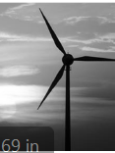
2020 Question 12 (b)
A thermometer is used to measure temperature.
- What is meant by temperature?
- Body temperature is 37 °C. Convert this to kelvin (K).

A thermometer is based on a particular thermometric property.
- What is a thermometric property?
- Name one example of a thermometric property.
- An uncalibrated thermometer is one that has no markings or numbers on it.
Describe an experiment to calibrate a thermometer.

2020 Question 12 (c)
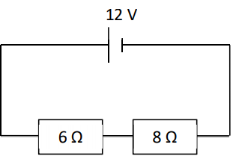
An electric current is a flow of electric charge.
A material that allows electric charge to flow through it is called an electrical conductor.
- Name a material that is an electrical conductor.
- What is the name given to a material that does not allow electric charge to flow through it?
- Describe an experiment to show that a material is an electrical conductor.
- Calculate the total resistance in the circuit shown above.
- Calculate the current flowing in the circuit.

2020 Question 12 (d)
- When the nuclei in certain atoms undergo radioactive decay, they emit one or more types of radiation – alpha, beta and gamma.
Which type of radiation is the most penetrating?

- Describe an experiment to compare the penetrating power of alpha, beta and gamma radiation.

The nuclear equation below shows the alpha decay of an isotope of radon.

$${Rn}_{86}^{220}→X_{A}^{Z}+ α_{2}^{4}$$
- Calculate the atomic number, A, of the unknown element X.
- Calculate the mass number, Z.
- Name element X.
- State one use of nuclear radiation.

